Alberta May Species Count 2021

Beauvais Lake Provincial Park
Date: June 5, 2021
Compiler: Teresa Dolman
Participants: Asher Warkentin
Area Covered: Within the Park
Weather: Temp. 17 to 19ºC
Wind speed: 35 to 55 km/hr.
Wind direction: W
Precipitation: none
Team Distance/Hours: Total team mileage: 11.3 km; by vehicle 0 km; on foot 11.3 km
Total team hours: 5.9 hr; by vehicle 0 hr; on foot 5.9 hr.
Number of Species: 52
Number of Birds: 177

BowKan Birders
Date: May 29, 30, 2021
Compiler: Clifford Hansen
Participants: Sue Arledge Kevin Barker, Wendy Bush, Dammika (from abroad), Nancy Davis, Ethon Denton, Mary Dumka, Graeme Duncan, Ron Dutcher, Marilynn Dyck, Pat Gaudet, Gian-Duri Giger, Wayne Haas, Cliff Hansen, Margo Hansen, Jenjira (from abroad), Caroline Lambert, Meg Nicks, Jason Reid, Laura Reid, Rose Reid, Joan Saunders, Hanne Seidel, Anita Walker, Blake Weis, Bill Wilson, Eva Zidek, (plus 3 un-named)
Area Covered: 15 km diameter circle centered on the north face of Mount McGillivray), just south of Exshaw.
Weather:
Day 1: Temp. 5 to 16ºC
Wind speed: 0 to 30 km/hr.
Wind direction: Westerly
Precipitation: nil
Comments: Pleasant day
Day 2: Temp. 5 to 19ºC
Wind speed: 0 to 25 km/hr.
Wind direction: Westerly
Precipitation: nil
Comments: Pleasant day
Team Distance/Hours: Total team mileage: 343 km; by vehicle 243 km; on foot 100 km. Total team hours: 69.25 hr; by vehicle 5 hr; on foot 64.25 hr.
Number of Species: 113
Number of Birds: 2885
Other species seen during count week: none
Highlights:
- The 17 Great Blue Herons counted is above the average of 11 but none were seen on their past ‘Heronry’ site on the north shore of Lac des Arcs. They apparently moved, but to where??
- There are variations from count to count in the number of birds by species. This year the most significant increases were Common Merganser (106 birds/Average 41), American Coot (122/24), and Savannah Sparrow (128/16). Most waterfowl were seen on Lac des Arcs and were migrating birds. All but a handful of Savannahs were seen in one sub-area of our count circle.
- The most significant decreases were Canada Goose (160/252), Mallard 37/100), and Cliff Swallow (3/189). The late spring snow probably delayed Canada Goose and Mallard hatches (young birds do increase the count often significantly) and delayed the return of the Swallows.
- For the first time we were able to count a House Finch. Purple (1/2) and Cassin’s (2/1) Finches were also seen.

Brooks Lake Newell
Date: May 22, 23, 2021

Compiler: Debra Hornsby: 403 431 2447

Participants: John Bargman, Lloyd Bennett, Judy Boyd, Larry Boyd, John Caddy, Irene Crosland, Cathy Cush, David Grinevitch, Trevor Grinevitch, Wes Grout, Howard Heffler, Lyn Heffler, Debra Hornsby, Ed Marchand, Ken Orich, Reg Orich, Brenda Pullen, Doug Pullen, Melanie Seneviratne, Nimali Seneviratne, Ena Spalding, Elaine Spitzer, Milt Spitzer, Joan Sveen, Michael Sveen, Donna Trathen, Les Trathen, Donna Wieckowski, Arthur Wieckowski

Area Covered: Brooks Circle

Weather:

Day 1: Temp. 4 to 8ºC

Wind speed: 15 to 20 km/hr.

Wind direction: shifting

Precipitation: occasional scattered light showers

Comments: Cloudy

Day 2: Temp. 5 to 8ºC

Wind speed: 15 to 30 km/hr.

Wind direction: shifting

Precipitation: heavy rain in the afternoon

Comments: rain shortened the count in some areas

Team Distance/Hours: Total team mileage: 1647 km; by vehicle 1641.5 on foot 5.5 km.

Total team hours 150 hr; by vehicle 145 hr; on foot 5 hr.

Number of Species: 147 (+ 6 CW)

Number of Birds: 37,049
Other species seen during count week: Gray-Cheeked Thrush, Orange-crowned Warbler, MacGillivray’s Warbler, American Redstart, Bay-breasted Warbler, Rose-breasted Grosbeak

Highlights: Record number of American Bittern and White-Faced Ibis seen. High numbers of N. Harriers and buteo species. 1st year no Baird’s Sandpiper. Lowest number of total species seen (not including CW birds).

Calgary and area
Date: May 29-30, 2021
Compilers: Terry Poulton, Lara Fitzpatrick, John McFaul, Andrew Hart
Participants: 102; names not available; 23 of them covered more than one area.
Area Covered: 20144 sq. km. One important foothills subarea, straddling forest and farmland north and west of Cochrane (15: Water Valley South) and regularly counted previous years, was not covered in 2021.
Weather:
Day 1: Temp. 2 to 25ºC
Wind speed: 0 to 30 km/hr. Mainly calm, sometimes light breeze.
Precipitation: None
Comments: Hot, clear or partly cloudy, sunny. Glenmore Reservoir very low, delta well exposed; Bow River somewhat high; Sheep River normal; Prairie ponds dry or low in some places, or other sloughs and wetlands with high water. Many bikers and hikers in parks and natural areas. Roads mainly dry and in good condition.
Day 2: Temp. 5 to 30ºC
Wind speed: up to 24 km/hr, from west. Strong winds in early morning in some places.
Precipitation: None
Comments: Sunny, clear and warm or with some clouds in places, calm or with light winds and gusts at higher altitudes. High traffic and dry dusty roads in some places, busy day-use areas. Some trails muddy.
Team Distance/Hours: Total team mileage: 4783 km; by vehicle 4417 km; on foot 366 km. Total team hours: 481 hr; by vehicle 251 hr; on foot 230 hr.
Number of Species: 207 (+9 CW)
Number of Birds: 70176
Other species seen during count week: 9 species: White-rumped Sandpiper (13), Sabine’s Gull (34), Blackpoll Warbler (1), Wild Turkey (1), Sprague’s Pipit (1), Dusky Grouse (1), Sedge Wren (1), Grey-cheeked Thrush (1), Great Egret (1).

Highlights: Once again, observers in the Calgary count were encouraged to submit their data into eBird, and 44 out of 52 subareas reporting complied. Of the remainder, some but not all observers in 3 subareas submitted reports by eBird. The results were compiled from eBird and from written or verbal reports by Andrew and John, and Lara created an impressive set of new Excel data sheets, analyses and a graphing tool, from which charts shown below were extracted.
The left axis (orange) in the chart below applies to the numbers of Party Hours and Birds per Hour; the right axis (green) refers to the Number of Birds. Since the count began recently to encourage the use of eBird for reporting, instructions to participants have been improved to acquire effort data (number of participants, kilometers covered, party hours, all increasing over the years of the count) to maintain consistency with reporting of earlier years. Howver, the last 2 years may contain minor anomalies relative to previous reports because of the change in reporting format. The numbers of Party Hours prior to 2003 shown in the chart below (left) (and in the shaded areas in the family group charts farther below) are interpreted from meager archival data and extrapolation backward from recent trends as explained in a report available at 10.13140/RG.2.2.32077.79849 , which also contains 1979-2018 charts for all the birds from the Calgary count and a summary of the count history.

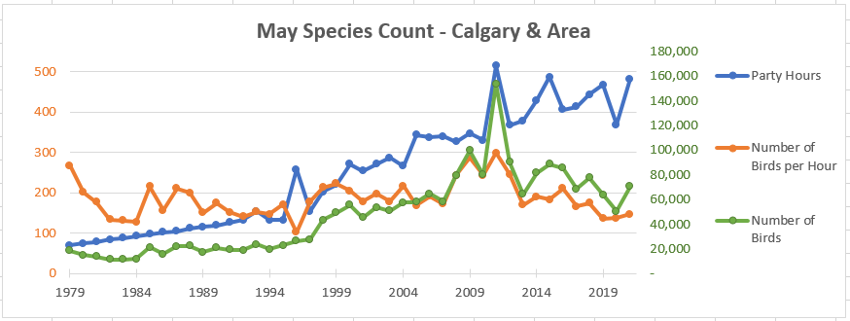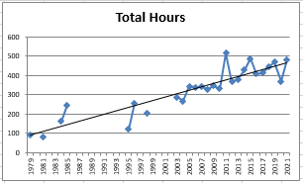

The total number of birds counted (70176) was up from a relatively low number last year, returning to the approximate level for the previous 8 years. The high records in 2009 and 2011 result from particularly favourable water levels for nesting of very large numbers of Franklin’s Gull at Frank Lake. Following those anomalous years, the Number of Birds counted has been dropping gradually, returning to 2000-2007 levels in spite of the significantly greater Numbers of Hours spent observing as well as other “effort” factors:

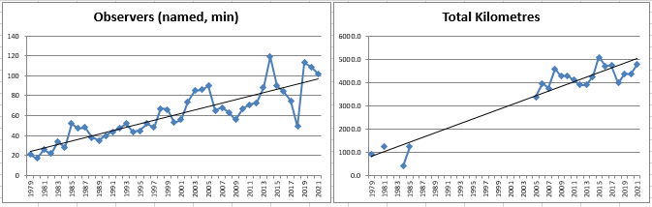

This recent downward trend is also seen more subtly in the Number of Species observed.

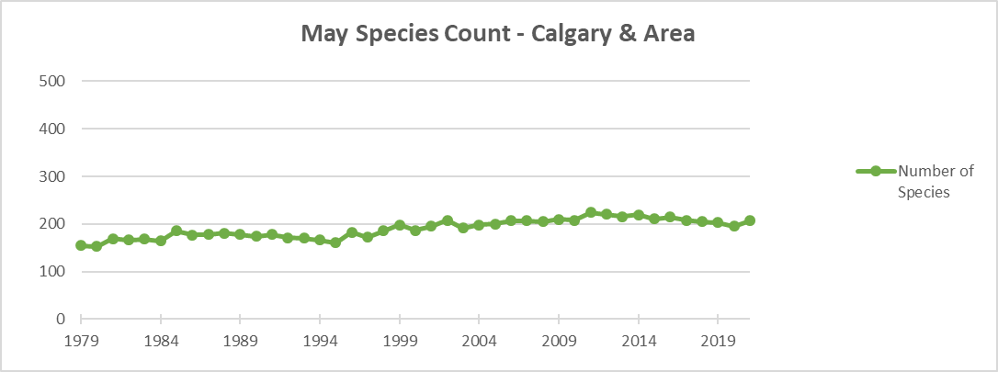

The numbers of 73 species were higher than the average of the last 10 years by 6% or more, of which 17 were more than double, the highest by 576% (Turkey Vulture, represented by 23 individuals). 21 species were within 5% either side of the 10-year average, and 103 species were lower. 87 species of the multi-year cumulative count total of 295 were not reported this year.
Lara noted that 2021 was a record year (highest since 1979) for nine species: Turkey Vulture, Wood Duck, American White Pelican, Black-necked Stilt, Bobolink, American Avocet, Bald Eagle, House Finch, Hairy Woodpecker. Several are obviously very well adapted fairly new entrants into the area. All but the Hairy Woodpecker had counts more than double the 10-year average. However, the trendline normalized for the Party Hours for the Hairy Woodpecker since the beginning of the count in 1979 is about level, and that for the American Avocet is downward.
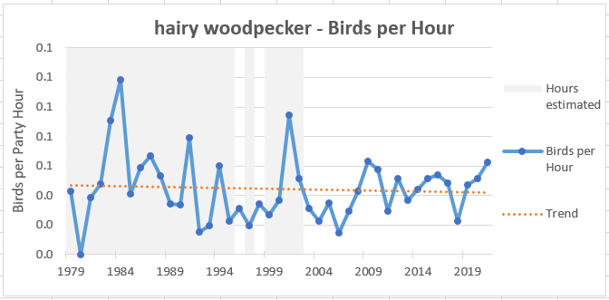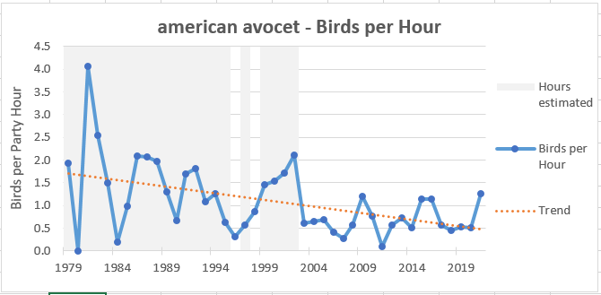

Lara also noted that there were a few (7) unusual species reported this year (species that have been seen 10 or fewer times since the beginning of the Calgary count): Long-tailed Duck, Cassin's Finch, Turkey Vulture, Virginia Rail, Brewer's Sparrow, Arctic Tern, Pacific Wren. In particular, the Cassin's Finch has been detected only twice before in MSC history.
On the downside she also recognized a number of missing regulars this year (i.e. species seen in at least 7 of the last 10 years, but not this year): White-winged Scoter, Long-billed Curlew, Northern Goshawk, MacGillivray's Warbler, Blackpoll Warbler (one was seen during Count Week). The total number of birds is 14% below the most recent 10-year average, the number of species 4% lower. No new species have been reported since 2016.
The charts below illustrate how the increasing numbers of birds (left side) in a few major groups are not as positive when they are normalized by dividing by the Number of Party Hours (right side), as strikingly shown in the chart for the large Hawks, Owls and Falcons. We continue to analyze the charts.

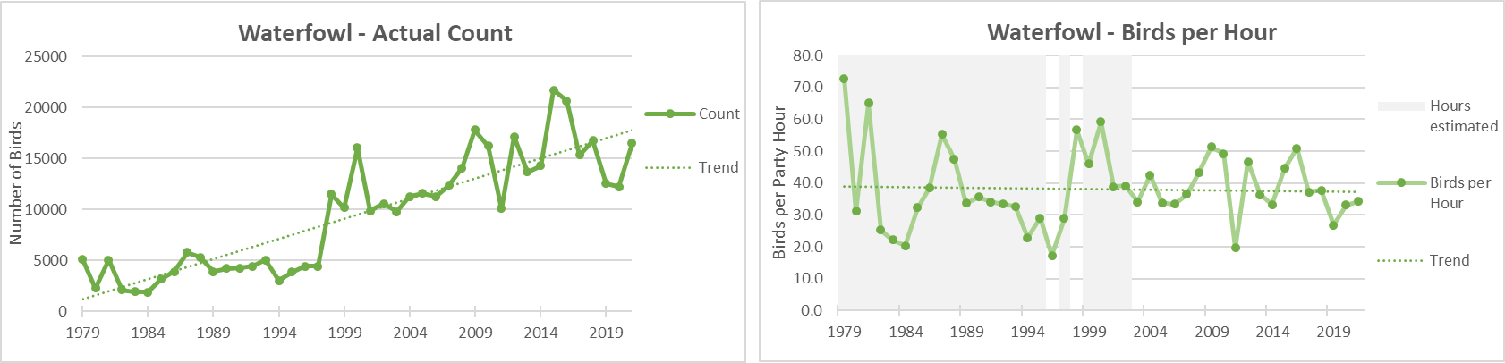

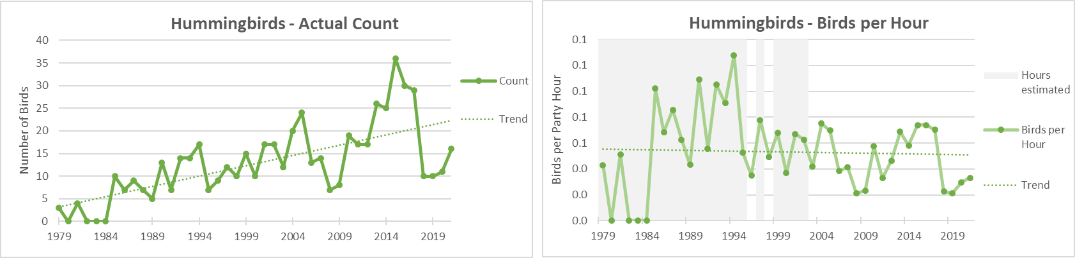

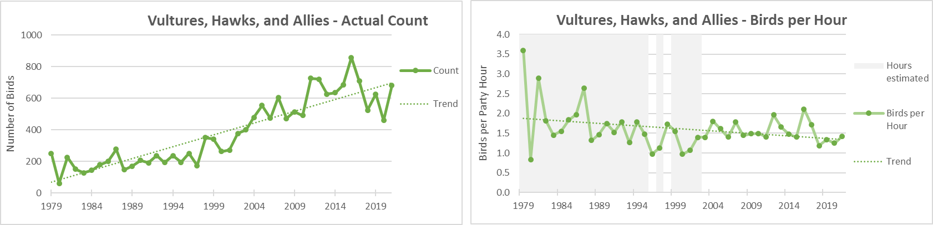

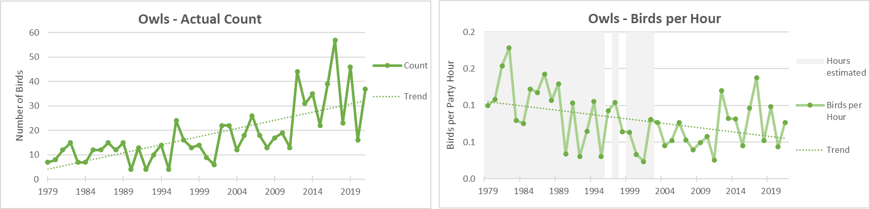

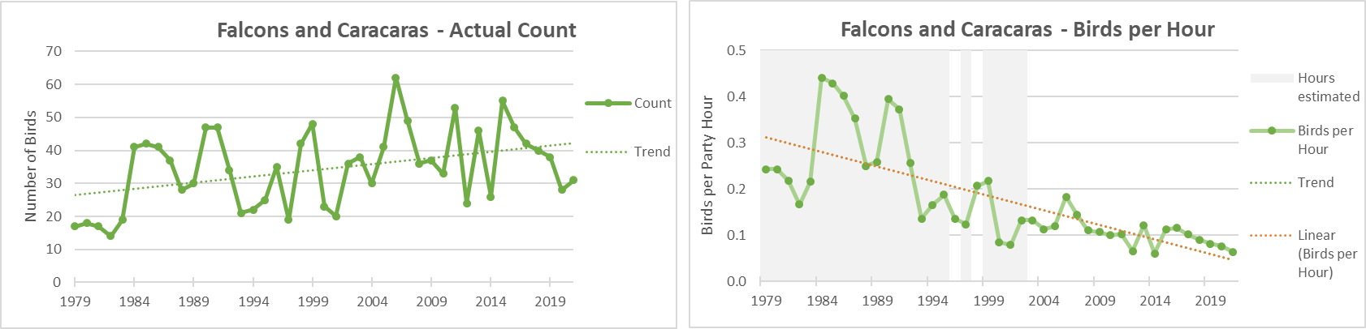

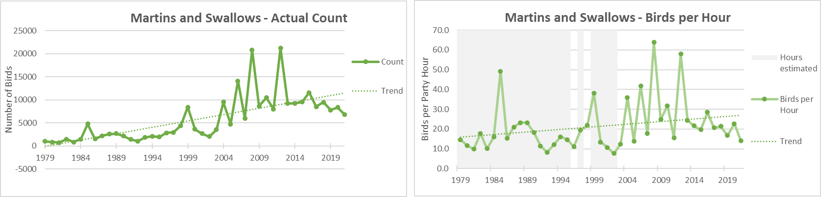

Central Alberta (Red Deer and area)
Date: May 29, 30, 2021
Compiler: Judy Boyd
Participants: 90 – Bill Barritt, Linda Bergman, Brian Biggs, Adrian Bjorge, Karin Bjorge, Myron Bjorge, Jim Boyce, Judy Boyd, Larry Boyd, Terry Brauner, Rob Brennen, Connie Brooks, Richard Brooks, Lois Burkinshaw, Phil Burkinshaw, Colleen Caddy, Jerry Caddy, John Caddy, Ed Cameron, Sandra Cameron, June Campbell, Morris Flewwelling, Eileen Ford, Stewart Ford, Georgie, Betty Ann Golly, Byron Golly, Isabelle Golly, Stuart Golly, Theresa Golly, William Golly, Gordon Graham, Sharon Graham, Darren Grose, Karen Grose, Rick Guest, Sharon Guest, Angela Hall, Blake Hall, Bill Heinsen, Colin Hill, Glenda Hill, Karen Hill, Shaye Hill, Marlene Ironside, Wayne Johnson, Keith Kline, Dom Kmet, Larry Kowich, Jim Leslie, Sue Leslie, Claudia Lipski, Brenda Lissel, Diane Lutz, Doug Lutz, Carol Lynass, Shelley Macauley, Gwen Marshall, Lynda Marshall, Mark Meunier, Ruby Meunier, Dorothy Murray, Sandy Murray, Antonia Nissen, Clint Nissen, James Nissen, Juanita Nissen, Chris Olsen, Sheryl Paquette, Myrna Pearman, Doug Pedersen, Rose Primus, Jim Potter, Linda Prockiw, Aleksandra Pugajski, Darlene Reimche, Ed Reimche, Veronica Reist, Heather Saunders, Sheri Skocdopole, Joanne Susut, Harvey Sutherland, Rick Tallas, Bev Thompson, Sandy van Dijk, Rick Varjassy, Zack Vopni, Althea Williams, Diane Wilton, Kevin Wingert
Area Covered: Zone 1 (Red Deer), Zone 2 (Sylvan Lake), Zone 3 (Gull Lake), Zone 4 (Lacombe), Zone 5 (Ellis Bird Farm), Zone 6 (Pine Lake), Zone 7 (Penhold), Zone 8 (Dickson, MRWC), Zone 9 (Condor, Stauffer), Zone 13 (Ponoka), Zone 14 (Clive), Zone 15 (Alix), Zone 16 (Lousana), Zone 17 (Bigelow Reservoir), Zone 18 (Davey Lake), Zone 19 (Bowden), Zone 22 (Didsbury), Zone 23 (Didsbury), Zone 25 (Three Hills), Zone 26 (Dry Island Buffalo Jump), and Zone 27 (Rocky Mountain House).
Weather:
Day 1: Temp. 5 to 25ºC
Wind speed: 0 to 40 km/hr. Wind direction: variable
Cloud cover: 0-95%
Day 2: Temp. 5 to 25ºC
Wind speed: 0 to 25 km/hr. Wind direction: variable
Cloud cover: 0-40%
Team Distance/Hours: Total team mileage: 19936.14 km; by vehicle 1848.3 km; on foot 87.84 km. Total team hours: 272 hr 41 min; by vehicle 105 hr. 48 min; on foot 61 hr 8 min; feederwatch 102 hr. 45 min; owling 3.
Number of Species: 151
Number of Birds: 24028
Highlights: Highest recorded numbers since 2000: Canada Goose, Gadwall, Mallard, Blue-winged Teal, Cinnamon Teal, Northern Shoveler, Lesser Scaup, Bufflehead, Common Goldeneye, Ruffed Grouse, Pied-billed Grebe (same as in 2012), Black-crowned Night-Heron, White-faced Ibis, Turkey Vulture, Bald Eagle, Swainson’s Hawk, Red-tailed Hawk (same as in 2008), Sandhill Crane, Black-necked Stilt, American Avocet, Spotted Sandpiper, Willet (same as 2015), Wilson’s Phalarope, California Gull, Ruby-throated Hummingbird, Downy Woodpecker, Alder Flycatcher (same as 2012), Common Raven, Tree Swallow, Northern Rough-winged Swallow, Cliff Swallow, Barn Swallow, Red-breasted Nuthatch, White-breasted Nuthatch, American Robin, Ovenbird, Yellow Warbler, Yellow-rumped Warbler, Red-winged Blackbird, Yellow-headed Blackbird, Common Grackle, Brown-headed Cowbird, Baltimore Oriole, Purple Finch, House Finch, House Sparrow.
This is the first time a Northern Shrike has been recorded sinch 2000.
Number of participants was up from last year's 83 to 90. The number of bird species went up from last year's 142 to 151. (The highest recorded number of species since 2000 was in 2008: 153.) The count of individual birds was up from last year's 17,112 to 24,016.
Mammals: White-tailed Deer, Muskrat, Thirteen Lined Ground Squirrel, Richardson’s Ground Squirrel, Mule Deer, Elk, Coyote, Woodchuck, Pronghorn, Snowshoe Hare, Chipmunk, Red Squirrel
Amphibians: Boreal Chorus Frog, Wood Frog
Insects: Mourning Cloak, Sulfur butterfly, Tiger Swallowtail, Skippers, Damselfly, Dragonfly, Bumblebee, Spring Azure, White Cabbage butterfly

Cardston
Date: May 31, June 1, 2021
Compiler: Lloyd Bennett
Compiler’s phone number: 403-223-0456
Participants: Lloyd Bennett, Yolanda Bennett, Bob Pruner, Emily Pruner
Area Covered: Town of Cardston, St. Mary Reservoir campground, Police Outpost Provincial Park, Woolford Provincial Park and Highway 501 southeast of Cardston.
Weather:
Day 1: Temperature Range: 17 to 24°C
Wind speed: 5 to 16 km/hr
Wind direction: variable
Precipitation: none
Day 2: Temperature Range 15 to 28º C
Wind speed: 3 to 15 km/hr
Wind direction: W
Precipitation: none
Team Distance/Hours: Total team mileage: 253 km; by vehicle 250 km; on foot 3 km.
Total team hours: 13.25 hr; by vehicle 9.5 hr; on foot 2.75 hr; watching feeders 1 hr.
Number of Species: 101 (+6 CW)
Number of Birds: 1068
Other species seen during count week: Sandhill Crane, Great Horned Owl, Belted Kingfisher, Merlin, Red-breasted Nuthatch, Red Crossbill
Highlights: After a hiatus of six years, the Cardston count was conducted this year. The number of species of birds tallied, 101, was very close to the long-term average of 99 as calculated from the 34 previous years of this count. Amongst those 101 species, however, were three that had never been recorded before – Northern Mockingbird (a rare bird for Alberta), Caspian Tern and Cassin’s Vireo. In addition, Cooper’s Hawk and MacGillivray’s Warbler were seen for just the second time ever, Black-necked Stilt and Olive-sided Flycatcher for the only the third time and Hooded Merganser for only the fourth time.
Mammals Observed: 1 White-tailed Jack Rabbit, 47 Richardson’s Ground Squirrels, 3 Columbian Ground Squirrels, 3 Beavers, 2 Deer Mice, 2 Meadow Voles, 1 Muskrat, 2 Coyotes, 1 Red Fox, 10 Mule Deer, 8 White-tailed Deer, 3 Pronghorns.

Cold Lake
Date: May 29-30, 2021
Compiler: Ted Hindmarch
Participants: 25 Field, 3 FW (10 parties Day 1, 12 parties Day 2): Phil and Mado Shore, Ron and Nancy Donnelly (Cold Lake); Chris Etue (Rapid View, Sask); Richard Klauke (Ashmont); Ben Evans (Smokey Lake); Bob Bidney (Bon Accord); Delores Steinlicht, Imran Hayat, Steve Knight, Bob Parsons (Edmonton); Plus at large eBird reporters: Don and Gavin McKinnon, Ethan and Leon Denton, Peter Thompson, Michelle Schreder, Liz Soria, Lorna Aynbinder and Alan Knowles (Calgary); Bruce de Labio (Carp, Ont – tied for 6th as Canada’s top eBirder); Donna Franke +1, Terry Zurbrigg +1, Rita Fowell (unknown); Feeder watchers: Ray Coates, Linda Fraser, Bill Parker.
Area Covered: 20 Mi RADIUS COUNT CIRCLE CENTER 5427.30N 11030.00W
Cold Lake Provincial Park, English Bay, North Bay, HorseShoe Bay and Marina, Jesse and Charlotte Lake, Ernestina Lake, Angling Lake, Ethel, Hilda and Marie Lakes, Manitokan Lake, Moose Lake PP and Muriel Lake MD Park. This covered areas within WR51-55, WR40-45, WR30-33, WR 20-22, WR10-14, and WR01-04. Crane and Tucker Lake and Imperial Oil SAGD area (WR23,24,25 and WR 34,35) were not covered this count.
Weather:
Day 1: Temp 5 to 17C.
Wind speed: Very windy throughout day. 13-25km/h in AM gusting up to 55km/h by noon. 26 to 41 km/h in PM with gusts to 57km/h. W to NW throughout day.
Precipitation: Previous days rain ended overnight. No precipitation.
Comments: 16.75 hours of visible light. Temps below seasonal values (8 to 21C). Mostly Cloudy.

Day 2: Temp. 5 to 19 ºC
Wind speed: 1 to 18 km/h. Gusts of up to 29 km/h in PM, variable W to WSW.
Precipitation: None
Comments: Temps just slightly below seasonal average (7 to 20C). Mostly sunny through day.
Team Distance/Hours: Total team mileage: 689 km; by vehicle 636 km; on foot 39 km, bike 14km; Total team hours: 140 hr; by vehicle 56 hr; on foot 50 hr; by bike 1 hr; Feeder watch 33 hr
Number of Species: 171 (186 with CW)
Number of Birds: 13,015
Other species seen during count week: 15 (1 x Snow Goose, 1 x Sharp-Tailed Grouse, 1 x Virginia Rail, 1 x Yellow Rail, 1 x Whimbrel, 1 x Dowitcher sp, 12 x Red-Necked Phalarope, 1 x Horned Lark, 3 x Sedge Wren, 3 x Cape May Warbler, 4 x Blackpoll Warbler, 1 x Nelson’s Sharp-Tailed Sparrow, 6 x Western Meadowlark, 1 x House Finch, 1 x Lazuli Bunting).
Highlights:
Cold Lake ran its 21st Annual May Species Count on the last weekend in May (May 29/30). Of note the tally of 171 sp on the weekend was exceeded only on 7 previous counts. The additional 15 CW species brought total to 186, which was also exceeded only on 7 previous counts.

The individual numbers of 25 participants include eBirders that were in the area, specifically providing extensive coverage of hotspots and helping to fill out numbers. Where multiple reports came from a given area, only the highest individual count or unreported species were used in the count numbers. A big thanks to our annual participants who year after year travel the rural roads to cover many of the lesser visited areas in the count circle.

With travel and social distancing restrictions due COVID-19 continuing in 2021, the count was conducted again this year through small bubble groups and reports were forwarded through eBird, Emails, and other correspondence. As compiler, I personally did not participate in the count. Despite the restrictions, count results exceeded historic averages. COUNT WEEKEND TOTAL 171 (Average Weekend Count over past 20 yrs 164.6); with 15CW the total was 186 (Average with CW over past 20 yrs 174.2).
The Cold Lake area experienced a dry early spring, followed by some late snow and rainy periods in May. Water levels were down, & some marshes dried up around Cold Lake. This negatively impacted the area as a migration stopover for shorebirds. A couple of stopover spots at Charlotte, Jesse and Sandy Lake, however, yielded the few shorebird species reported.

Waterfowl numbers this year were led by American Coot, followed by Canada Goose, Northern Shoveler, Mallard, Eared Grebe, Blue-Winged Teal and Western Grebe. Highlight was 35 of C Listed Pacific Loon and a single B list Snow Goose. Franklin’s Gull numbers were back up again this year after a low count in 2020 but Black Tern numbers remained relatively low. The small group of Sabine’s Gulls was also a nice find as they have become more regular on our count, as were the 2 Caspian Terns. Good number of American Avocets topped the shorebird numbers; however, the highlight was the discovery of Black-Necked Stilts at the far east end of Charlotte Lake south of Fort Kent – these turned out to be up to 3 breeding pairs. An additional count highlight was a report of our first White-Faced Ibis for the count history – observed in a slough alongside Hwy 28 SW of Cold Lake. A Count Week Whimbrel was another great count bird. Cliff Swallow, Red-winged Blackbird, and Tennessee Warbler were the top three in the passerine category. We continued to have Bobolink observations in the Charlotte Lake area first reported in this area in 2019, and a small number of extended range migrating Lark Sparrows were again reported at a Cold Lake North feeder stopover.

22 of the possible 22 Warbler species were observed with Tennessee Warbler and Ovenbird topping the numbers. Cape May and Blackpoll, however, were only reported as CW observations. 8 of the 22 were reported in numbers of 5 or less.

Broad-Winged Hawk sightings were up this year with 12 reports. Owl reports were down this year with only 2 species reported. One list B Great Horned Owl, and one List C Short-Eared Owl.
NEW COUNT SPECIES:
White-Faced Ibis. 1st record: Liz Soria in Hwy28 roadside slough SW of Cold Lake https://ebird.org/canada/checklist/S89236217
C List Birds (less than 25% of counts): 12
Sharp-Tailed Grouse (CW): 3rd record. 1 observed by Bill Parker, Forest Drive, Cold Lake North Feeder watcher.
Cinnamon Teal: 6th record. Moves species to B List. 2 at Charlotte Lake observed/photographed by Ben Evans: https://ebird.org/checklist/S89209590
Pacific Loon: 4th record. 35. 28 observed by Gavin McKinnon’s (+4) Calgary Big Year Squad, along with Liz Soria and Michelle Schreder at North Bay https://ebird.org/checklist/S89267428, https://ebird.org/checklist/S89266490. 7 observed by Bruce Di Labio in English Bay https://ebird.org/checklist/S89310462. Smaller numbers (probable flock remnants) were also seen by 4 other observers at the North Bay location later in the morning
Black-Necked Stilt: 2nd record. 1st was 2005. 6 (includes CW reports). East end Charlotte Lake. 2nd breeding record for Checklist area. 2 were first reported in the area by Richard Klauke on 10 and 11 May https://ebird.org/checklist/S87875768 with Mathieu Langlois observing 6 on 13 May (https://ebird.org/canada/checklist/S87987772 ) This small extra-limital colony of BNSTs remained around through the count and was confirmed nesting and later in June was seen with young. Ben Evans and Steve Knight/Bob Parsons parties observed 3 of the birds on count weekend. https://ebird.org/checklist/S89209590 Both Richard and Ben observed an occupied nest: https://ebird.org/canada/checklist/S89297621. These sightings were supported by CW sightings by Richard Klauke on 28 (4) and 31(5) May: https://ebird.org/checklist/S89154402 and https://ebird.org/checklist/S89354991
Whimbrel: 3rd CW record. 1 observed/photographed by Bruce Di Labio along Cold Lake North shoreline: https://ebird.org/checklist/S89351903
Short-Eared Owl: 5th record. 1 observed by Gavin McKinnon flying across hwy west outskirts of Bonnyville. https://ebird.org/canada/checklist/S89249761
Yellow-Bellied Flycatcher. 3rd record. 1 of this elusive species observed and photographed by Alan Knowles and Lorna Aynbinder along the North Bay access road https://ebird.org/checklist/S89237111
Lazuli Bunting: CW. 2nd record. 1 observed/photographed by Ron Donnelly at his feeder in Cold Lake South 2 Jun https://ebird.org/checklist/S89484282
Horned Lark: CW. 6th record. Moves species into B list. 2 reported by Alan Knowles and Lorna Aynbinder in the English Bay area. https://ebird.org/checklist/S89169554
Lark Sparrow: 4th record. Small flock of 5 observed by Bill Parker, Forest Drive, Cold Lake North during feeder watch. ID by Merlin.
Bobolink: 3rd record. Small colonies again observed in the Charlotte Lake area. Although only 1 was observed on count weekend by Ben Evans https://ebird.org/checklist/S89169554, Richard Klauke reported 5 on the 28th. https://ebird.org/checklist/S89154402. Additionally, Liz Soria and Michelle Schreder observed 1 at the south end of Cold Lake’s Long Bay CW 26 May: https://ebird.org/checklist/S89012228
House Finch: 3rd record. Richard Klauke Charlotte Lake area 28 May https://ebird.org/checklist/S89154402
B List Birds observed on only 25-75% of counts: 23 of 42 B list species reported (includes CW)
Reported: Snow Goose, Surf Scoter, Hooded Merganser, Northern Goshawk, Swainson’s Hawk, Virginia Rail (CW), Semipalmated Plover, White-rumped Sandpiper, Baird’s Sandpiper, Pectoral Sandpiper, Dowitcher Sp (prob LBDO), Red-Necked Phalarope CW), Sabine’s Gull, Caspian Tern, Great-Horned Owl, Common Nighthawk, Philadelphia Vireo, Bank Swallow, Gray Catbird, Nashville Warbler, Palm Warbler, Bay-Breasted Warbler, Nelson’s Sharp-Tailed Sparrow (CW).
Missing from List B: Great-White Fronted Goose, Ross’s Goose, Cooper’s Hawk, Peregrine Falcon, Black-Bellied Plover, Ruddy Turnstone, Barred Owl, Northern Saw-whet Owl, Three-toed Woodpecker, Black-backed Woodpecker, Golden-Crowned Kinglet, Mountain Bluebird, Veery, Cedar Waxwing, American Tree Sparrow, Harris Sparrow, Lapland Longspur, Rusty Blackbird, White-Winged Crossbill.
A List Birds 75-100% of counts: 150 of 151 observed (includes CW). List A birds Missing In Action this count; American Golden Plover

Coyote Lake
Date: May 29, 30, 2021
Compiler: Javan Green
Participants: Janice Green, Javan Green, Penny Green, Richard Krikun, Nicole Krikun
Area Covered: Coyote Lake, Pigeon Lake (west shore), Battle Lake, Strawberry Creek
Weather:
Day 1: Temp. 10 to 20ºC
Wind speed: 0 to 25 km/hr.
Wind direction: W
Precipitation: N/A
Day 2: Temp. 7 to 23ºC
Wind speed: 0 to 25 km/hr.
Wind direction: S
Precipitation: N/A
Team Distance/Hours: Total team mileage: 298 km; by vehicle 290 km; on foot 8 km.
Total team hours: 11.5 hr; by vehicle 5 hr; on foot 6.5 hr.
Number of Species: 92
Number of Birds: 885
Other species seen during count week: N/A
Highlights: Connecticut Warbler, Mourning Warbler, Sandhill Crane, Trumpeter Swan

Crooked Lake, Athabasca County
Date: May 29, 30, 2021
Compiler: Joan Sherman
Participants: Joan Sherman (only)
Area Covered: Mixedwood boreal forest, lake edge and outlet creek
Weather:
Day 1: Temp. 8 to 18ºC
Wind speed: 15 to 28 km/hr.
Wind direction: NW
Precipitation: None
Comments: Lake water choppy, unable to see waterfowl
Day 2: Temp. 13 to 21ºC
Wind speed: 12 to 24 km/hr.
Wind direction: SW
Precipitation: None
Comments: Lake water choppy, unable to see waterfowl
Team Distance/Hours: Total team mileage: 8 km; by vehicle 0; on foot 8 km.
Total team hours: 7 hr; by vehicle 0 hr; on foot 7 hr.
Number of Species: 53
Number of Birds: 339
Other species seen during count week: none

Fort McMurray
Date: May 29, 30, 2021
Compiler: Christine Godwin
Participants: 20 people
Area Covered: Areas north, south and in town of Fort McMurray
Weather:
Day 1: Temp. 3 to 22ºC
Wind speed: 5 to 35 km/hr.
Wind direction: NNW
Precipitation: none
Comments: partly cloudy, calm in the morning, winds picked up in the afternoon
Day 2: Temp. 8 to 24ºC
Wind speed: 5 to 30 km/hr.
Wind direction: NE
Precipitation: partly cloudy
Comments: winds gusty in the afternoon
Team Distance/Hours: Total team mileage: 269.36 km; by vehicle 198.2; on foot 71.16 km. Total team hours: 60.9 hr; by vehicle 18.9 hr; on foot 42 hr.
Number of Species: 133 (+2 CW)
Number of Birds: 3111
Other species seen during count week: Common Nighthawk, American Goldfinch
Highlights: Baltimore Oriole, active raven nest, Ruddy Duck

Lac la Biche
Date: May 29, 30, 2021
Compiler: Jennifer Okrainec
Participants: Dave Cheyne, Heather Dempsey, Nathan, Joe Neiderleitner, Jennifer Okrainec, Cooper Okrainec, Jacob Okrainec, Lois Philips, Jim Skladan, Melissa Spiddell, Stacy St. Jean
Area Covered:
Weather:
Day 1: Temp. 10 to 18ºC
Wind speed: 16 to 28 km/hr.
Wind direction: NW
Precipitation: nil
Day 2: Temp. 11 to 22ºC
Wind speed: 6 to 15 km/hr.
Wind direction: W
Precipitation: nil
Team Distance/Hours: Total team mileage: 358 km; by vehicle 354 km; on foot 4 km.
Total team hours: 60 hr; by vehicle 39 hr; on foot 4 hr. feeder 8 hr; by boat 9 hr.
Number of Species: 128 (+1 CW)
Number of Birds: 2908 (+1 CW)
Other species seen during count week: Western Wood-Pewee.

Lethbridge
Date: May 29, 30, 2021
Compiler: Teresa Dolman
Participants: Gordon Butt, Linda Cerney, Douglas Dolman, Teresa Dolman, John Dubbelboer, Graeme Greenlee, Pat Greenlee, Samantha Krause, Jennifer Mather, Ted Nanninga, John Nightingale, Ken Orich, Johnal Palahniuk, Bob Pruner, David Scott, Emma Scott, Brook Skagen, Mira Vanhala, Evan Walters, Jay Yanke.
Areas Covered: City of Lethbridge parks and neighbourhoods, Park Lake Provincial Park, Keho Lake, CPR Lake, Turin area, Barnwell area, Coaldale Birds of Prey Centre, West Ridge Stewardship Project, Raymond area, Magrath area
Weather:
Day 1: Temp. 10 to 19ºC
Wind speed: 5 to 24 km/hr.
Wind direction: W
Precipitation: none
Day 2: Temp. 10 to 23ºC
Wind speed: 4 to 22 km/hr.
Wind direction: S
Precipitation: none
Team Distance/Hours: Total team distance: 167.1 km (88.8 km by vehicle, 78.3 km on foot).
Total team hours: 53.1 hr (9.5 hr by vehicle, 41.6 hr on foot, 2 hr watching feeders)
Number of Species: 132 (+9 CW)
Number of Birds: 6042
Other species seen during count week: Green-winged Teal, Great Blue Heron, Ferruginous Hawk, Yellow-bellied Sapsucker, Northern Mockingbird, Mountain Bluebird, Harris’s Sparrow, Tennessee Warbler, Northern Waterthrush.
Highlights: For the 46 years that this count has been going, the average number of birds recorded is 117. We surpassed that handily this year by tallying 132 species, with another nine added during count week. Although no new species were added to the overall list, Pileated Woodpeckers were found for only the second time, Blue-headed Vireo and Ovenbird for only the third time, and MacGillivray’s Warbler for only the fourth time.
Several count week birds were noteworthy. Harris’s Sparrow is seen occasionally on migration and a few manage to overwinter here. They breed in the arctic and are generally gone by May, but in 2008 one lingered long enough to be found for the spring count. Northern Mockingbird is considered a rare bird for Alberta and it, too, has been recorded only once on the Lethbridge spring count, in 1980.

Medicine Hat
Date: May 30, 2021
Compiler: Marty Drut
Participants: Judy Anderson, Barry Anderson, Dee Armstrong, Hugh Armstrong, Darlene Black, Jim Black, Eileen Cowtan, Marty Drut, Fay Felesky, Val Felesky, Corlaine Gardner, Rob Gardner, Jill Gatfield, Sue Higgins, Pam Hodgkinson, Annalora Horch, Phil Horch, Ian Langill, Charmaine Leidal, Cam Lockerbie, Jane McGough, Bruce McLeod, Amy Moores, Mark Oxamitny, Sandi Robertson, Dan Schiebelbein, Mark Schiebelbein, Lorrie Sielski, John Slater, Milt Spitzer, Elaine Spitzer, Donna Steele, Angela Turner, Ian Turner, Michael Velner, Eric Vokes, Rob Wapple, Carol Wickenheiser, Christy Wickenheiser, Jeremy Williamson, Barrett Wolski
Area Covered: Medicine Hat and surrounding areas
Weather: Temp. 6 to 24ºC
Wind speed: 7 to 19km/hr.
Wind direction: S - SW
Precipitation: None
Team Distance/Hours: Total team mileage: 707.5 km; by vehicle 599; on foot 108.5 km
Total team hours: 104 hr; by vehicle 35.5 hr; on foot 57 hr.
Number of Species: 119 (+1 CW)
Number of Birds: 8,629
Other species seen during count week: Common Nighthawk
Highlights: The 37th Spring Count had relatively seasonal temperatures (high 24º C, low 6º C) and light winds (S - SW, 7-19 km/hr). Despite these good conditions, both species and individual birds were down from last year. Species decreased 14% from 139 to 119; 2021 total species was 9% less than the 4-year average of 131. Individual birds declined 14% from 10,073 in 2020 to 8,629 in 2021 and 8% from the 4-year average of 9,388 (see Data Summary Table, page 3). Warm and windy afternoon conditions reducing bird activity and impacts from drought may have contributed to these changes.
There were 7 species with an all-time high count: Eurasian-collared Dove, Northern Flicker, Blue Jay, Black-capped Chickadee, Common Grackle, White-winged Crossbill, and Common Redpoll (see Table 1, page 2). In addition to these high counts, 7 species showed notable upticks in 2021 including Long-billed Curlew, Wilson’s Phalarope, Least Flycatcher, Black-billed Magpie, Cliff Swallow, American Robin, and House Finch (see Species Table, page 6). Three species had all-time lows in 2021 including American Kestrel, Marbled Godwit, and Bank Swallow (see Table 1, page 2). This was the first count no Bank Swallows were observed. There were also 3 species that showed a decline for 3 years or more: these included Blue-winged Teal and American Crow. The third, Savannah Sparrow, showed declines over the past 5 years. Furthermore, three other sparrow species decreased from 2020 and included Chipping, Clay-colored, and Vesper. One additional decline that occurred was Eared Grebe observations went from 43 in 2020 to 0 in 2021 (see Species Table, page 6). No new species were observed in 2020. One species. Common Nighthawk was seen exclusively during count week but not on count day.
Species missing from this year’s count that were seen in 2020 included Green-winged Teal, Ring-necked Duck, Greater Scaup, Bufflehead, Ruddy Duck, Horned Grebe, Eared Grebe, American Bittern, Ferruginous Hawk, Solitary Sandpiper, Pileated Woodpecker, Willow Flycatcher, Blue-headed Vireo, Bank Swallow, Marsh Wren, Mountain Bluebird, Gray-cheeked Thrush, Sprague’s Pipit, Tennessee Warbler, Orange-crowned Warbler, Blackpoll Warbler, American Redstart, Yellow-breasted Chat, American Tree Sparrow, Grasshopper Sparrow, Baird’s Sparrow, White-throated Sparrow, Bobolink, and Evening Grosbeak. Nine additional species have been absent from the count two or more years: Western Grebe (2019), Sharp-tailed Grouse (2018), Sharp-shinned Hawk (2017), Caspian Tern (2019), Black Tern (2016), Short-eared Owl (2017), Wilson’s Warbler (2019), Brewer’s Sparrow (2019), and Chestnut-collared Longspur (2017).
Less frequently seen species observed in 2021 were Hooded Merganser (1), Pied-billed Grebe (2), American Avocet (5), Upland Sandpiper (1), Eastern Screech-owl (1), Olive-sided Flycatcher (1), Ruby-crowned Kinglet (1), Townsend’s Solitaire (1), Veery (1), Hermit Thrush (1), Pine Siskin (6), Rose-breasted Grosbeak (1), and Red and White-winged Crossbills (15 each species) (see Species Table, page 6). Some of these species had extended absences from the count: Pied-billed grebe was last observed in 2014, Eastern Screech-owl in 2001, Red Crossbill in 2013, and White-winged Crossbill in 2007.
The Top 10 for 2021 were European Starling (1,161), American Robin (905), Common Grackle (576), House (English) Sparrow (445), Canada Goose (436), Black-billed Magpie (400), Red-winged Blackbird (398), Yellow Warbler (382), Western Meadowlark (234), and House Finch (225). House Finch replaced Chipping Sparrow, which slipped to the 22nd position in 2021.
As for flowers, 53 species were observed in bloom, which was a 29% increase from last year. The later date for 2021 may have impacted the number of species in bloom (see Data Summary Table, page 3 and Flower List, page 5).
Count effort was excellent in 2021. Participants, distances covered, and hours of observation were similar to last year (see Data Summary Table, page 3). Masterpiece Southland Meadows took part for the second consecutive count. A colossal thank-you to everyone who volunteered their time this year, especially in light of the concurrent Covid-19 pandemic.
New Species Observed in 2021: None. Rare sightings of Pied-billed Grebe (2), Eastern Screech-owl (1), Olive-sided Flycatcher (1), and Red and White-winged Crossbills (15 each species)

Table 1. 2021 Spring Bird Count All Time High and Low Observations.

2021 Spring Bird Count – Highs and Lows
HIGHS
Species |  | High |  |  | Previous High |  | Year
Eurasian-collared Dove |  | 141 |  |  | 126 |  | 2018
Northern Flicker |  | 94 |  |  | 93 |  | 2018
Blue Jay |  | 43 |  |  | 34 |  | 2018
Black-capped Chickadee |  | 129 |  |  | 109 |  | 2016
Common Grackle |  | 576 |  |  | 480 |  | 2016
White-winged Crossbill |  | 15 |  |  | 9 |  | 2002
Common Redpoll |  | 4 |  |  | 2 |  | 2018 & 1998
LOWS
Species |  | Low |  |  | Previous Low |  | Year
American Kestrel |  | 1 |  |  | 3 |  | 2019
Marbled Godwit |  | 1 |  |  | 5 |  | 2015
Bank Swallow |  | 0 |  |  | 5 |  | 2003
DATA SUMMARY 2017 - 2021
 | May 30  2021 |  | May 24  2020 | May 26  2019 |  | May 27  2018 |  | May 28  2017
Total Individuals | 8,629 |  | 10,073 | 8,900 |  | 9,955 |  | 8,625
Total Bird Species | 119 |  | 139 | 128 |  | 129 |  | 128
Total Flower Species | 53 |  | 41 | 55 |  | 65 |  | 68
Participants | 49 |  | 56 | 40 |  | 36 |  | 38
Total Km Walked | 108.5 |  | 99.2 | 85 |  | 102.3 |  | 123
Total Km Driven | 591 |  | 568.5 | 495 |  | 556.5 |  | 530
Total Km Biked | 8 |  | 8 | 8 |  | 5 |  | -
Hours of Observation | 104 |  | 117 | 102.5 |  | 106.5 |  | 101.5
on foot: | 57 |  | 59.75 | 52 |  | 52 |  | 64.25
by car: | 33.5 |  | 44 | 45.5 |  | 47 |  | 35.25
by bicycle: | 2 |  | 1.5 | 2 |  | 1.5 |  | -
feeder: | 11.5 |  | 11.75 | 3 |  | 6 |  | 2

Milk River
Date: May 29, 30, 2021

Compiler: Debra Hornsby

Participants: Carmie Callanan, Bill Calvert, Lynn Calvert, Earle Covert, Cathy Cush Wes Grout, Debra Hornsby, Ed Marchand, Donna McKown, Doug McKown, Annette Orich, Ken Orich, Salina Perry, Brenda Pullen, Doug Pullen, David Rhody, Marilee Rhody, Arthur Wieckowski, Donna Wieckowski,

Area Covered: Milk River WOS Circle

Weather:

Day 1: Temp. 9 to 17ºC

Wind speed: 5 to 10k

Wind direction: light, shifting

Comments: Sunny with some clouds

Day 2: Temp. 9 to 20ºC

Wind speed: 5 km/hr.

Wind direction: shifting

Comments: sunny and clear

Team Distance/Hours: Total team mileage: 1498.5 km; by vehicle 1489 on foot 9.5 km.

Total team hours 92 hr; by vehicle 86 hr; on foot 6 hr.

Number of Species: 130 (+4 CW)

Number of Birds: 16,201
Other species seen during count week: Snowy Egret, Red-naped Sapsucker, Western Wood-Pewee, Lark Sparrow
Highlights: First ever Ruffed Grouse (2) and first Dunlin (confirmed with photo from participant eBird report). These bring the cumulative total species seen on count days for the count to 226. We also want to note the mammal species this year were impressive: a first ever family of swift fox, 8 badgers, more pronghorn than in previous years (many with twin young) and also a first ever racoon on the count.

Taber
Date: May 29, 30, 2021
Compiler: Lloyd Bennett
Participants: Lloyd Bennett, Mary Bennett, Yolanda Bennett, Murray Gardner, Charles Hart, Dorothy Hart, Ron Levagood, Betty Osing, Carol Tams
Area Covered: Taber & Vauxhall areas, Purple Springs Sand Dunes
Weather:
Day 1: Temp. 7 to 20°C
Wind speed: 3 to 13 km/hr
Wind direction: W
Precipitation: none
Day 2: Temp. 10 to 24º C
Wind speed: 3 to 16 km/hr
Wind direction: S
Precipitation: none
Team Distance/Hours: Total team mileage: 551 km; by vehicle 529 km; on foot 22 km.
Total team hours: 41 hr; by vehicle 24 hr; on foot 12 hr; watching feeders 5 hr
Number of Species: 130 (+2 CW)
Number of Birds: 8844
Other species seen during count week: Orange-crowned Warbler, Common Redpoll
Highlights: The number of species seen, 130, is slightly higher than the average of 126 for this count. One species was added to the overall list, a Northern Goshawk. Goshawks have been recorded three times on Taber Christmas Bird Counts, but never on a spring count. Sharp-tailed Grouse was seen for only the third time, while Bald Eagle, Semipalmated Sandpiper and Yellow-breasted Chat were found for just the fourth time. The count week Common Redpoll is another species recorded often on the Taber Christmas Bird Count but, like the Northern Goshawk, never before on a spring count.
Mammals Recorded: 10 White-tailed Jackrabbits, 125 Richardson Ground Squirrels, 1 (dead) Deer Mouse, 1 Sagebrush Vole, 1 Meadow Vole, tracks of Northern Pocket Gophers, 4 Muskrats, 3 Coyotes, 5 Red Foxes, tracks of Raccoons, 1 Badger, 1 (dead) Striped Skunk, 42 Mule Deer, 5 White-tailed Deer, 34 Pronghorns
Wakomao Lake
Date: May 30, 2021
Compiler: Jim Lange
Participants: Jim Lange
Area Covered: Wakomao Lake by Clyde
Weather: Temp. 12 to 23ºC
Wind speed: calm to 25km/h
Wind direction: S
Precipitation: none
Team Distance/Hours: Total team mileage: 57 km by vehicle. Total team hours; 6.75 hrs by vehicle
Number of Species: 43
Number of Birds: 521

Waterton Lakes National Park
Date: June 5, 6, 2021
Compiler: Teresa Dolman
Participants: Lloyd Bennett, Douglas Dolman, Teresa Dolman, Donna Dubbelboer, John Dubbelboer, Martine Dumont, Lois Everett, Bet Forsyth, Rex Forsyth, Emily Hu, Jack Hu, Sunny Hu, Sarah Lane, Norm Legault, Lori Mattis, Johnal Palahniuk, Gordon Petersen, Heather Robinson, Cathy Scrimshaw, Natalie Vieira-Lomasney, Aimee Weir, Bradley Yee.
Areas Covered: All roads and many hiking trails within the Park.
Weather:
Day 1: Temperature Range: 9 to 19°C
Wind speed: 25 to 46 km/hr
Wind direction: SW
Precipitation: 1 mm
Day 2: Temperature Range: 10 to 14º C
Wind speed: 17 to 33 km/hr
Wind direction: SW
Precipitation: none
Team Distance/Hours: Total team distance: 286.2 km (201 km by vehicle, 85.2 km on foot). Total team hours: 58.1 hr (19.5 hr by vehicle, 38.6 hr on foot)
Number of Bird Species: 106 (+8 CW)
Number of Birds: 1397
Other bird species seen during count week: Wood Duck, American Bittern, Bald Eagle, Great Horned Owl, Common Nighthawk, Hairy Woodpecker, Prairie Falcon, Dusky Flycatcher
Mammals: 1 Least Chipmunk, 1 Yellow-pine Chipmunk, 101 Columbian Ground Squirrels, 8 Golden-mantled Ground Squirrels, 3 Red Squirrels, 1 Meadow Vole, 1 Muskrat, 3 Black Bears, 1 American (Pine) Marten, 12 Elk, 12 Mule Deer, 5 White-tailed Deer, 6 Bison, 15 Bighorns
Highlights: Over the 37-year period that this count has been going, the average number of bird species tallied on count days is 108. Our total this year, 106, is just shy of the average and probably was owing to the windy conditions and a few showers on Saturday, when most participants went out birding. No new species were added to the overall list, but Turkey Vultures (three of them!) were seen for just the second time ever, Red Crossbill (a single bird) for just the fourth time, and Brown Creeper (another single bird) for just the fifth time. As usual, there were some birds normally seen every year but missed this year, such as Trumpeter Swan, Calliope Hummingbird, Ring-billed Gull, Northern Harrier, Townsend’s Solitaire and Baltimore Oriole.
As far as mammals are concerned, 14 species were seen. Two of these are uncommon (or at least uncommonly encountered) – Yellow-pine Chipmunk and American (Pine) Marten.

